

Vet Helper

Tracking pet records, appointments, medicine & billing

# Table of Contents

Table of Contents 2

1 Employee Users – Common Functions 3

1.1 Add pet 3

1.2 Pay bill 5

1.3 Schedule appointment 7

1.4 Add Owner 10

2 Administrator Users – Common Functions 12

2.1 Create account 12

2.2 Change password 15

3 Owner Users – Common Functions 17

3.1 View appointments 17

3.2 View bills 18

3.3 View pet’s medical records 20

4 Veterinarian Users – Common Functions 20

4.1 View medicine/medical records 20

4.2 Add medicine/medical records 23

4.3 Access employee features 25

# 1 Employee Users – Common Functions

## 1.1 Add pet

1. Log into the Vet system using your designated username and password

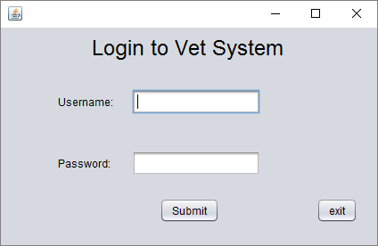

1. 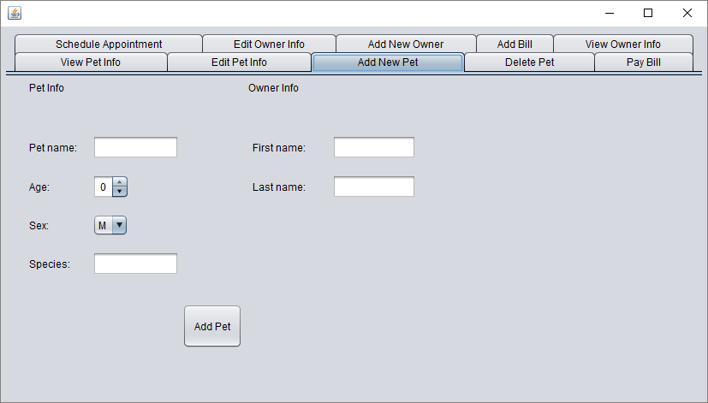Once logged in, navigate to the “Add New Pet” tab
2. Enter in the pet’s information, along with the owner’s first name and last name

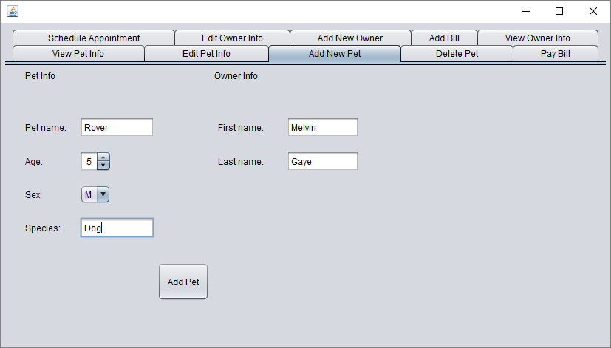

1. Click the “Add Pet” button to add the pet. If the pet was successfully added, you should receive a message box confirming the addition

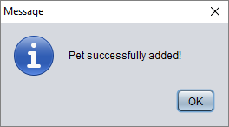

## 1.2 Pay bill

1. Log into the Vet system using your designated username and password



1. Once logged in, navigate to the “Pay Bill” tab
2. Enter in the owner’s first name and last name to view their bills

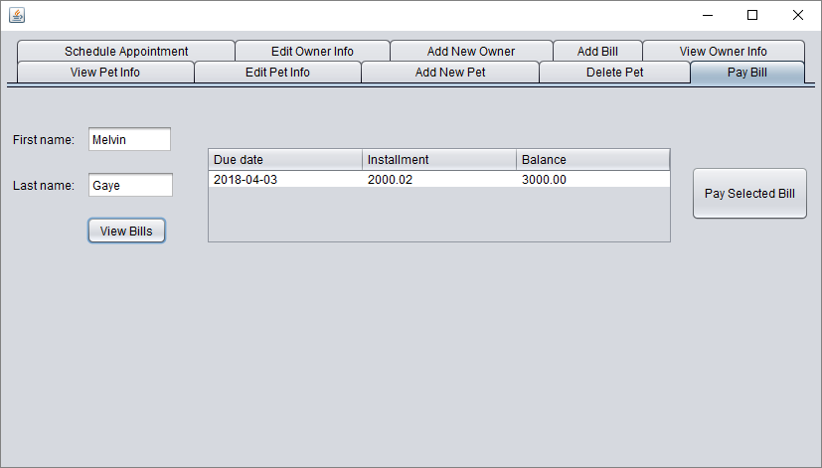

1. Highlight a bill in the table and click the “Pay Selected Bill” button

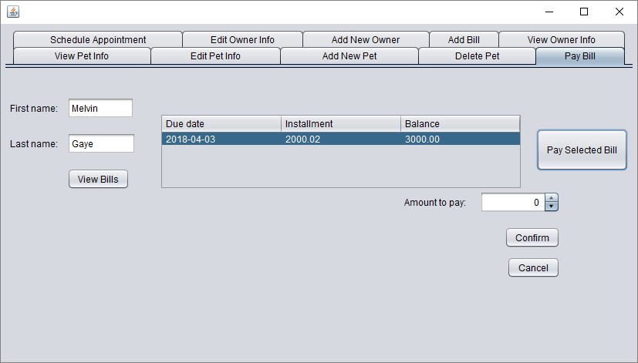

1. Enter in the amount the owner wishes to pay in the box labeled “Amount to pay” and press the confirm button. A dialog box should appear stating the amount paid, the remaining cost, and the due date

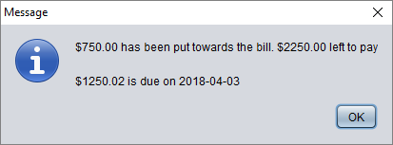

## 1.3 Schedule appointment

1. Log into the Vet system using your designated username and password



1. Once logged in, navigate to the “Schedule Appointment” tab and enter in the owner’s first name and last name to view their pets

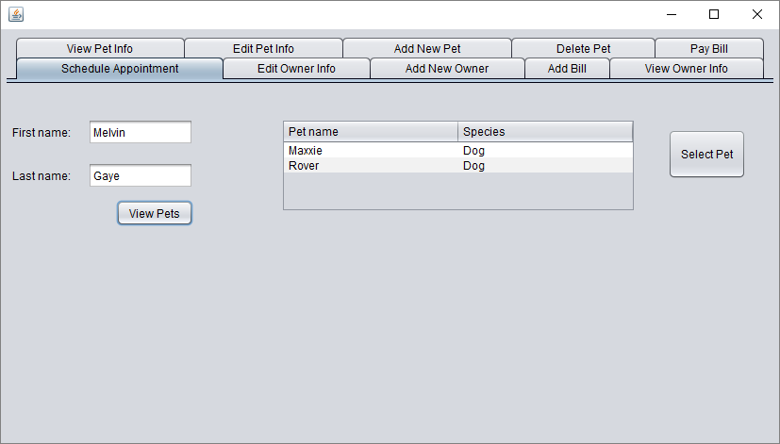

1. Highlight a pet in the table and press the “Select Pet” button

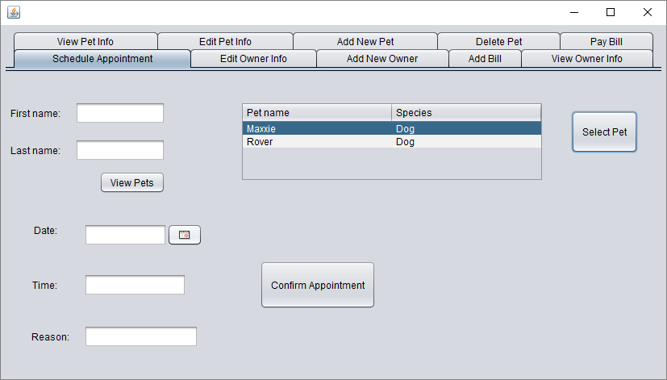

1. Enter in the appointment information

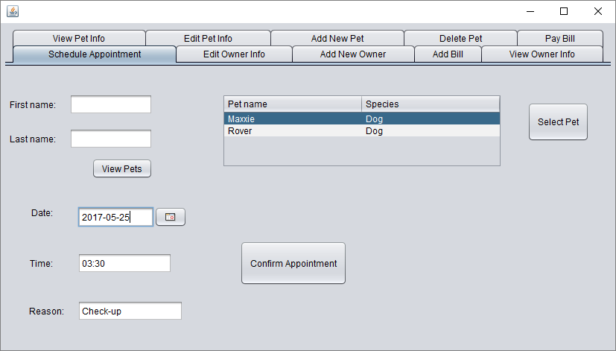

1. Click the “Confirm Appointment” button to save the appointment. A dialog box should appear to confirm

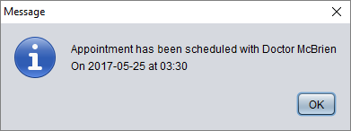

## 1.4 Add Owner

1. Log into the Vet system using your designated username and password



1. Once logged in, navigate to the “Add New Owner” tab and enter fill in the owner’s first name, last name, address, and phone number

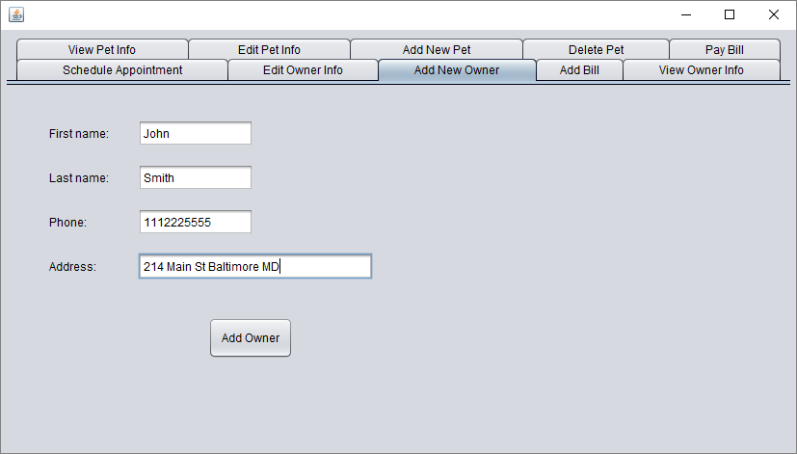

1. Click the “Add Owner” button to finalize the information and add the owner. A message dialog should appear to confirm the new owner

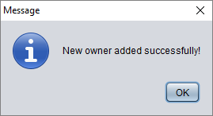

# 2 Administrator Users – Common Functions

## 2.1 Create account

1. Log into the Vet system using your designated username and password



1. Once logged in, navigate to the “Create account” tab

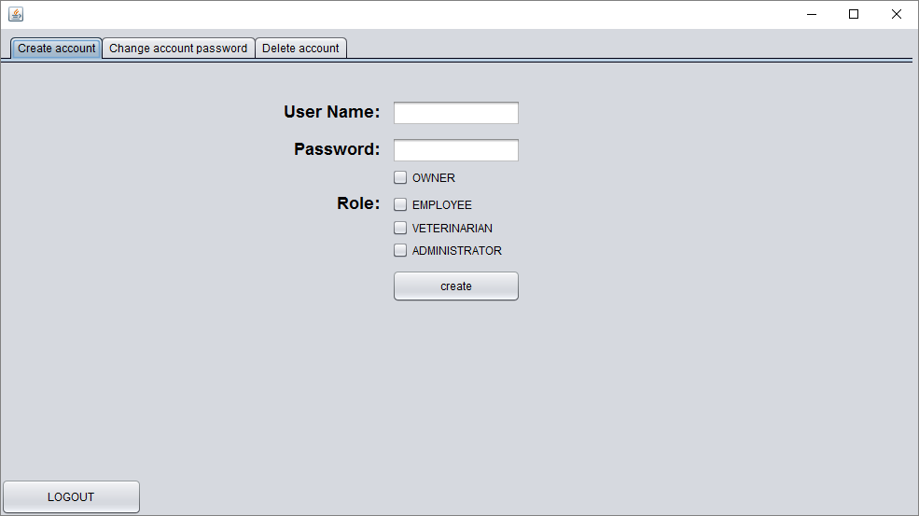

1. Enter in the user name and password for the new account and select the account type

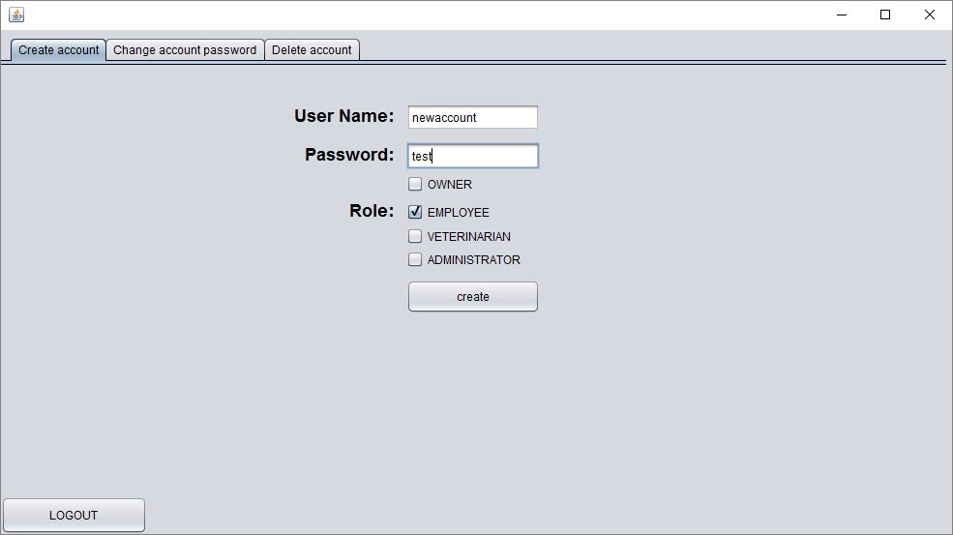

1. If the account is an owner account, the owner’s first name, last name, and phone number also must be entered

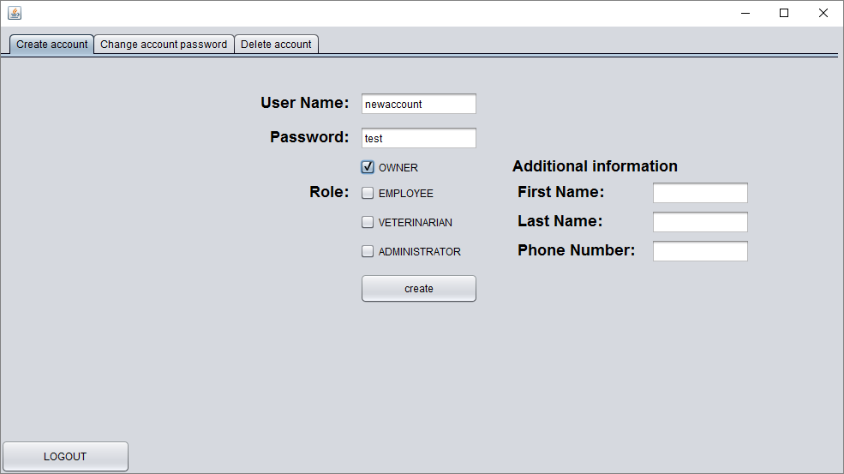

1. If the account is a veterinarian account, all the vet’s information must be added. The “Add Vet” button will complete the account creation

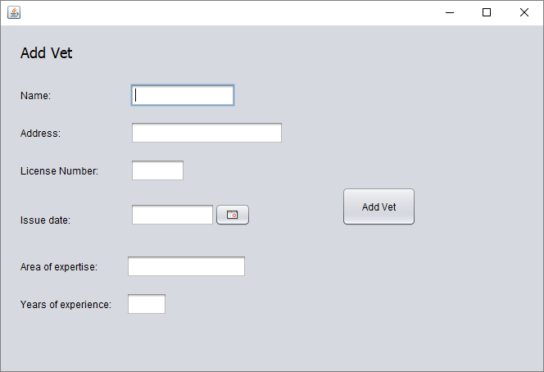

1. 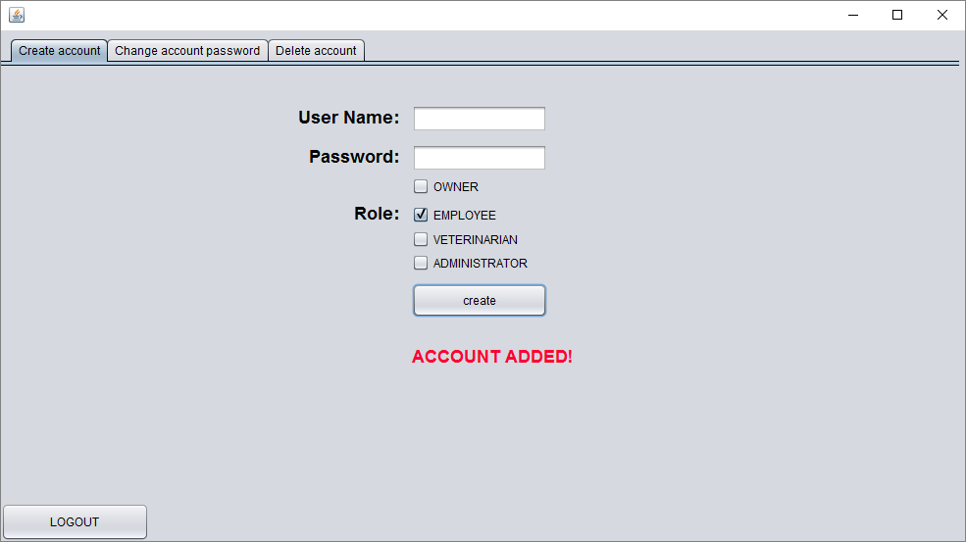Otherwise, click the “Create” button to create the account. A message dialog will appear confirming the new account

## 2.2 Change password

1. Log into the Vet system using your designated username and password



1. 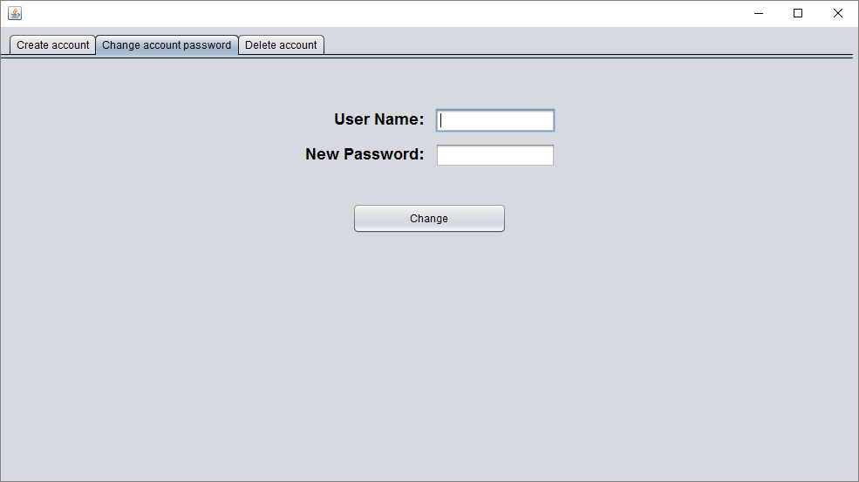Once logged in, navigate to the “Change account password” tab
2. Enter in the user name and new password and click the “Change” button

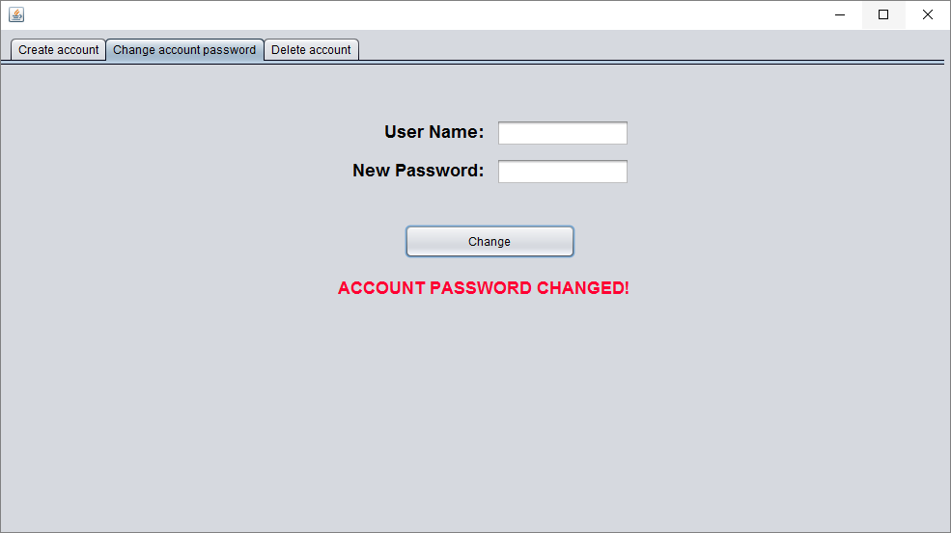

# 3 Owner Users – Common Functions

## 3.1 View appointments

1. Log into the Vet system using your designated username and password



1. 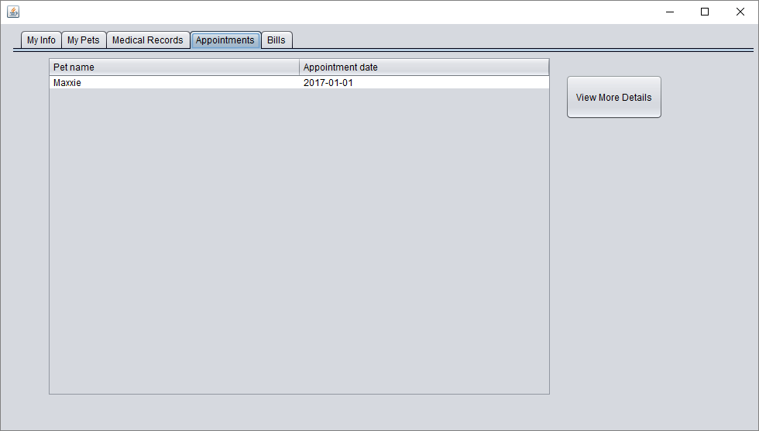Once logged in, navigate to the “Appointments” tab
2. 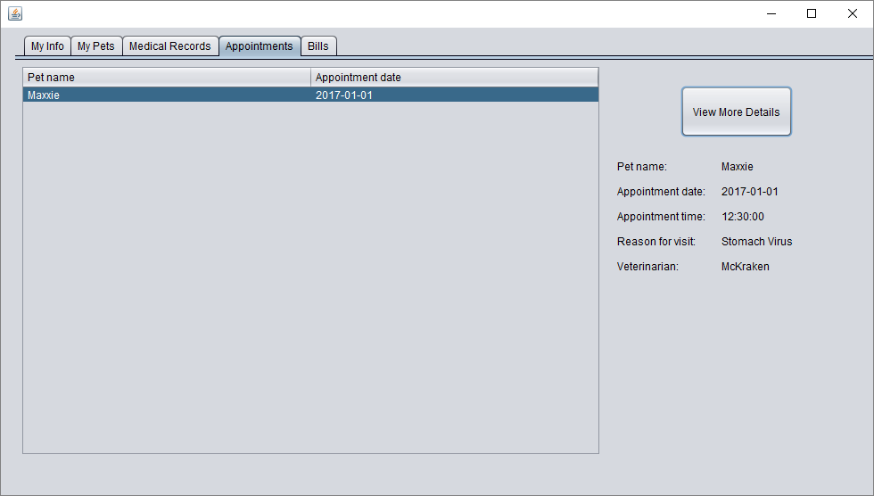Select a pet in the table and click the “View More Details” button. All information is then displayed

## 3.2 View bills

1. Log into the Vet system using your designated username and password



1. Once logged in, navigate to the “Bills” tab. All bills are loaded automatically

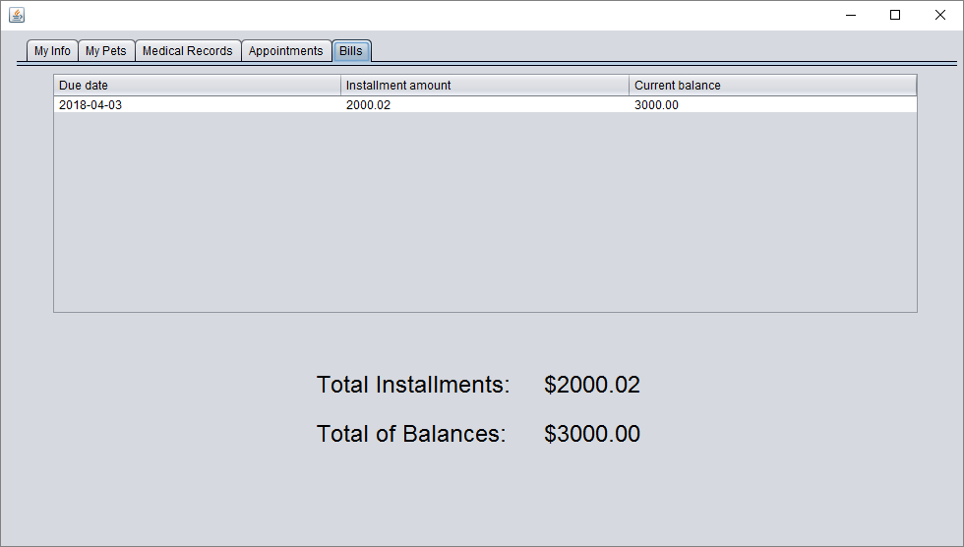

## 3.3 View pet’s medical records

1. Log into the Vet system using your designated username and password



1. Once logged in, navigate to the “Medical Records” tab. All records are loaded automatically

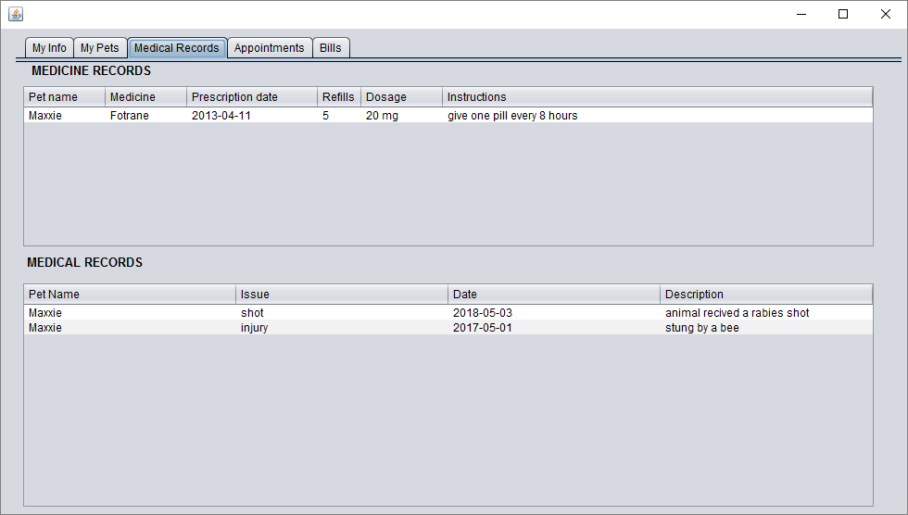

# 4 Veterinarian Users – Common Functions

## 4.1 View medicine/medical records

1. Log into the Vet system using your designated username and password



1. Enter the pet’s id or the pet’s name and owner’s last name to view a specific pet

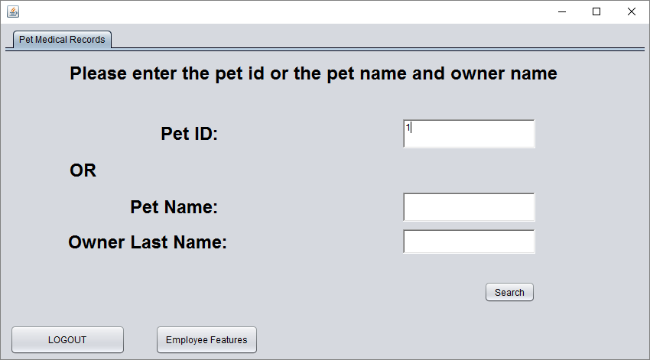

1. To view the pet’s medical records, navigate to the “Medical records” tab to view them

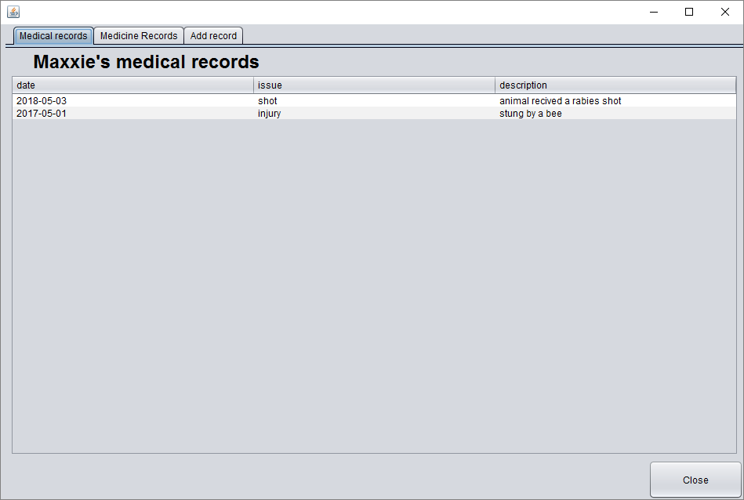

1. 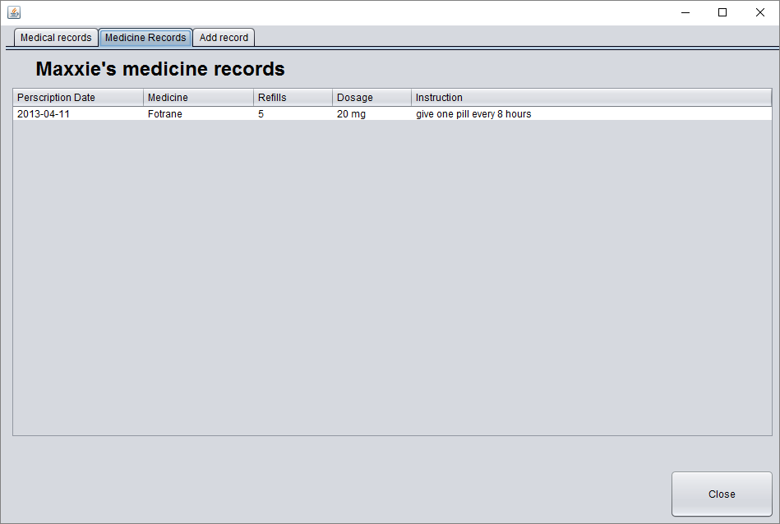To view the pet’s medicine records, navigate to the “Medicine Records” tab to view them

## 4.2 Add medicine/medical records

1. Log into the Vet system using your designated username and password



1. Enter the pet’s id or the pet’s name and owner’s last name to view a specific pet



1. Navigate to the “Add record” tab to enter information

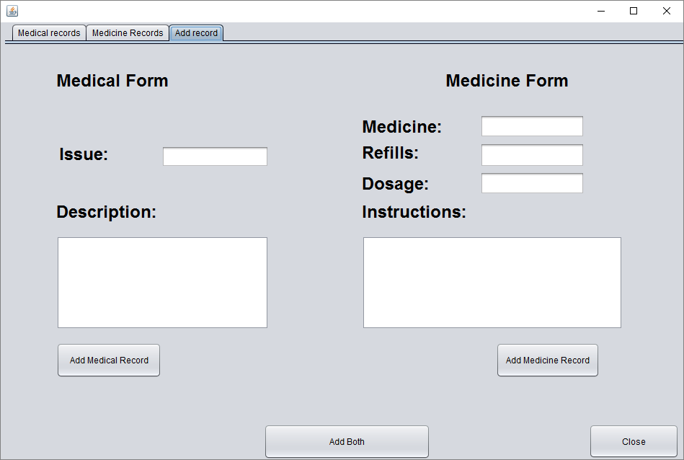

1. 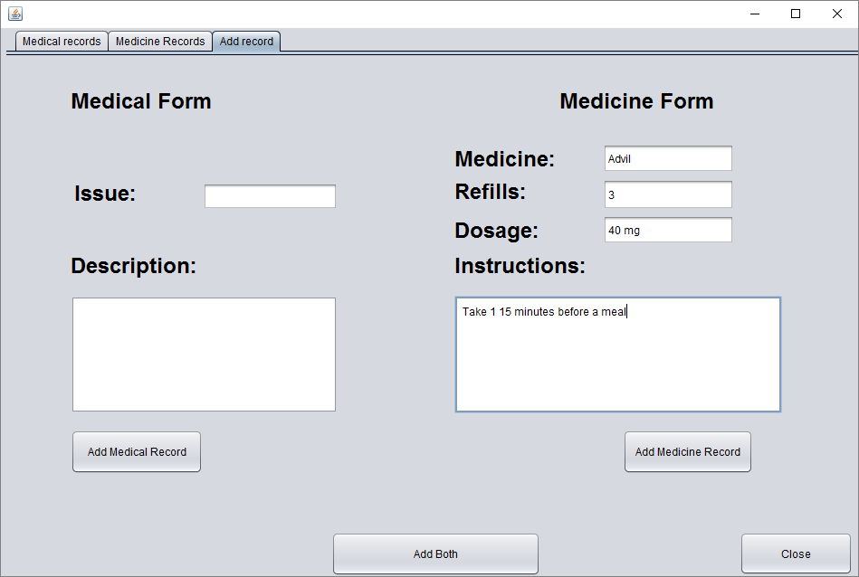Use the “Medicine Form” to fill out information on prescriptions/medicines
2. Click “Add Medicine Record” to enter the information, or if a Medical Form is also filled out, click “Add Both”

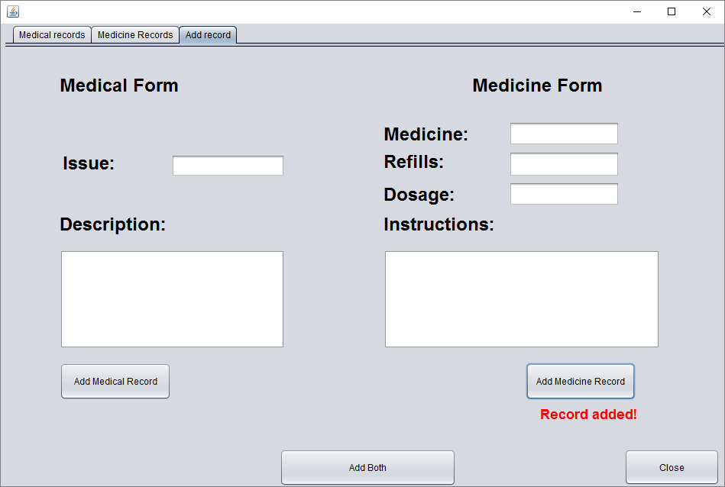

1. Fill out a “Medical Form” for injuries/shots/etc.

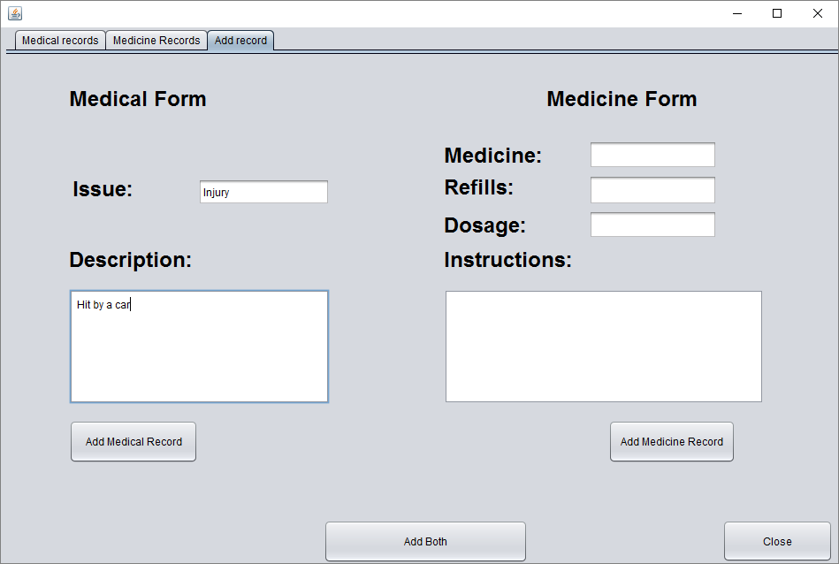

1. Click the “Add Medical Record” to finalize the record, or if a Medicine Form is also filled out, click “Add Both”

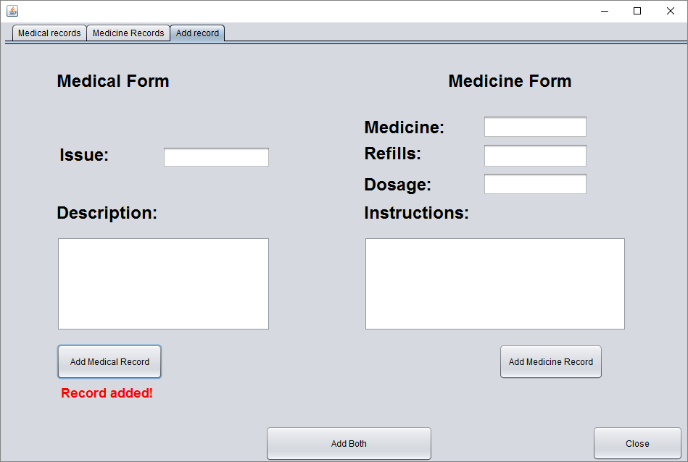

## 4.3 Access employee features

1. Log into the Vet system using your designated username and password



1. Select the “Employee Features” button



1. The employee screen will appear for the vet

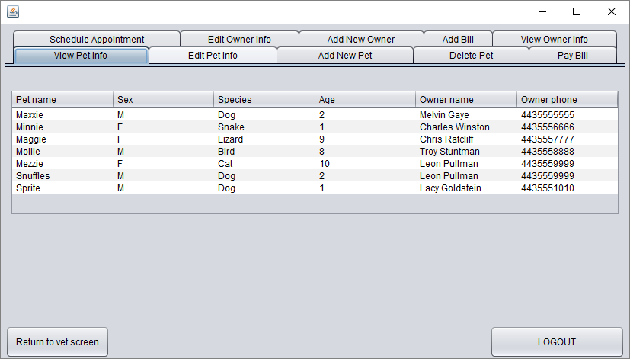

1. Click the “Return to vet screen” to return and access the vet only features

